Ideation Phase
Brainstorm & Idea Prioritization Template

Date | 28 September 2026
Team ID | SWTID-2026-6232
Project Name | AI WeatherWise API
Maximum Marks | 4 Marks

Brainstorm & Idea Prioritization Template:
Brainstorming provides a collaborative environment where the team can freely share ideas and explore different possibilities for solving a problem. In the AI WeatherWise API project, the brainstorming process focused on identifying useful weather services, AI-powered features, secure user access, and an easy-to-use RESTful API structure.
The team encouraged creative ideas without immediately judging them, allowing different features such as weather information, AI summaries, recommendations, stories, poems, and chatbot assistance to be discussed and developed. After collecting the ideas, they were grouped and prioritized based on their importance to the project, user usefulness, and future enhancement possibilities.
Use this brainstorming and prioritization approach to organize the team's ideas, identify the core features of AI WeatherWise API, and shape them into a practical project solution.

Step-1: Team Gathering, Collaboration and Select the Problem Statement
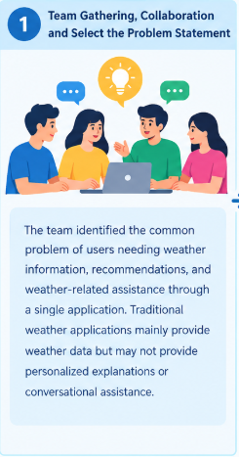

Step-2: Brainstorm, Idea Listing and Grouping
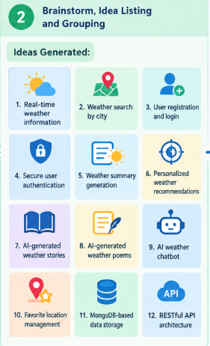

Step-3: Idea Prioritization
